Diffusion-Limited Aggregation
I. Introduction
Many attractive images and life-like structures can be generated using models of physical processes from areas of chemistry and physics. One such example is diffusion limited aggregation or DLA which describes, among other things, the diffusion and aggregation of zinc ions in an electrolytic solution onto electrodes. "Diffusion" because the particles forming the structure wander around randomly before attaching themselves ("Aggregating") to the structure. "Diffusion-limited" because the particles are considered to be in low concentrations so they don't come in contact with each other and the structure grows one particle at a time rather then by chunks of particles. Other examples can be found in coral growth, the path taken by lightning, coalescing of dust or smoke particles, and the growth of some crystals. Perhaps the first serious study of such processes was made by Witten, T.A. and Sander, L. M. and published by them in 1981, titled: "Diffusion limited aggregation, a kinetic critical phenomena" in Physical Review Letters. number 47.
The DLA process lead to a fractal colony, so the fractal dimension of the DLA pattern become attractive us to study for identification and description of spatial distribution. However, to define what a fractal is, first consider the coastline of Great Britain. To measure the length of the coastline we need a ruler; with a meter stick, we measure the coastline and get a total length. Now with a smaller ruler, we measure it again and obtain a longer length. As we use smaller and smaller rulers, we obtain longer and longer lengths. If we use larger and larger rulers we obtain smaller and smaller total lengths. Because the coastline wiggles, the length is different when using different sized rulers. The coastline is considered to be a self-similar fractal if the length, as a function of the size of the ruler, follows a power law. To determine the fractal dimension of the aggregate, first consider N(R), the number of particles that are closer than some distance R away from the center of mass. For a solid object in one dimension, the number is proportional to R. In two dimensions, this number is proportional to R². In three dimensions, this number is proportional to R³. Lacunarity is a counterpart to the fractal dimension that describes the texture of a fractal. It has to do with the size distribution of the holes. Roughly speaking, if a fractal has large gaps or holes, it has high lacunarity; on the other hand, if a fractal is almost translationally invariant, it has low lacunarity. Different fractals can be constructed that have the same dimension but that look widely different because they have different lacunarity. There are applications of lacunarity in image processing, ecology, medicine, and other fields, thus we should take in to account the lacunarity with this model.
This Article is organized as follows. First, we clearly define the model, the fractal dimension , lacunarity and two-point disconnected correlation. This is done in section II. In section III, the Monte Carlo (MC) simulation result and discussion are given. We summarize our results and make some comments in the last section.

II. Model
We start with a two-dimensional square lattice of dimensions$L×L$. Each lattice site is denoted by a pair of integers$\vec{r}=(i,j)$. To model the DLA systems consisting of two species of particles, we allow each site to be occupied by either a gray particle (“spin up”), a white particle (“spin down”), or a vacancy/black particle (“spin zero”). The gray particles are randomly distributed with density D on a lattice that has a white particle at the origin of the lattice. Each gray particle is allowed to walk randomly from far away until it is attached to the white. If a gray particle sticks to a white particle, it changes to be the white particle and can not walk. The Monte Carlo step ( MCS )can be defined by the step when all the particles in the lattice have walked or tried to walk once. The process repeats until there are no free particles. The lattice has brick wall boundary conditions and conservation of particles. Multiple-occupancy is forbidden. A configuration in the model will be described by a set of spin variables$\left\{σ_{\vec{r}}\right\}$ which can take three values:$σ_{\vec{r}}\text{=+}1(−1)$for a gray (white) particle and$σ_{\vec{r}}=0$ for a vacancy (black). The initial configuration will be a completely random distribution, i.e., the gray particles will occupy the whole system with density D and the density of vacancy will be1-D. The single white particle will initially be located at the origin. We measure the fractal dimension and lacunarity of the final pattern with respect to the density of particles and the two-point disconnected correlation function with time at some densities. Our data are averaged over 10³ realizations (or runs) with the system size 81.
How to measure the fractal dimension, lacunarity ,and two-point disconnected correlation function
The fractal dimension is calculated using a box counting method. From a grid overlaying the lattice, the box counting routine counts the number of boxes of a given size that contain any cells. To approximate the scaling behavior, box counting uses a series of grid sizes. To minimize grid size effects, the range for epsilon (grid dimension) should go from 1 cell to the lesser of the maximum dimension across the pixelated area horizontally or vertically ( for this case we use epsilon =3, 9, 27, and 81 ). The fractal dimension is –1 times the slope of the regression line, from a plot of the log of size on the x-axis and the log of count on the y. It is calculated here using the method of least squares.
For the lacunarity, we use the gliding-box algorithm, developed by Allain and Cloitre, as follows. A box of length r is placed at the origin of one of the sets. The number of occupied sites within the box (box mass equal to s) is now determined. The box is moved one space along the set and the box mass is again counted. This process is repeated over the entire set, producing a frequency distribution of the box masses n(s,r). This frequency distribution is converted into a probability distribution Q(s,r) by dividing by the total number of boxes N(r) of size r. the first and second moments of this distribution are now determined:
$$\begin{aligned}Z(1) = \sum{\text{sQ}}(s,r), (1) \\ Z(2)=\sum{s^{2}}Q(s,r)\text{.} (2)\end{aligned}$$
The lacunarity for this box size is now defined as
$$Λ(r)=Z(2)/[Z(1)]^{2}\text{.} (3)$$

The two-point disconnected correlation function G⁽²⁾(i,j), is defined to be
$G^{(2)}(i,j)≡σ_{i}σ_{j}>$ (4)
This function is a measure of the correlation between the value of spin particles $σ$ on the two sites; it takes a positive value if the values of spin particles$σ$ on those two sites fluctuate in the same direction together, and negative one if they fluctuate in opposite directions. If their fluctuations are completely unrelated, then its value will be zero. We calculate the two-point disconnected correlation function between the origin and other sites at different distances, going in four directions, to study the symmetry about the origin.
III. Results and Discussion
Performing the computer simulation of the DLA model, we have measured the fractal dimension and lacunarity by varying the density of particles, and the two-point disconnected correlation function with the origin in the four directions. The evolution of a typical configuration in a 273x273 lattice for D=0.1,0.17,and 0.5 is shown in Fig .1, Fig. 2, Fig.3 respectively. A filamental pattern can be seen in the case of low density of particles, and forming a compact phase and homogeneity for a high density. The low density system takes a longer time to reach the final state. We compare the final configurations for the different density of particles,Fig.4.

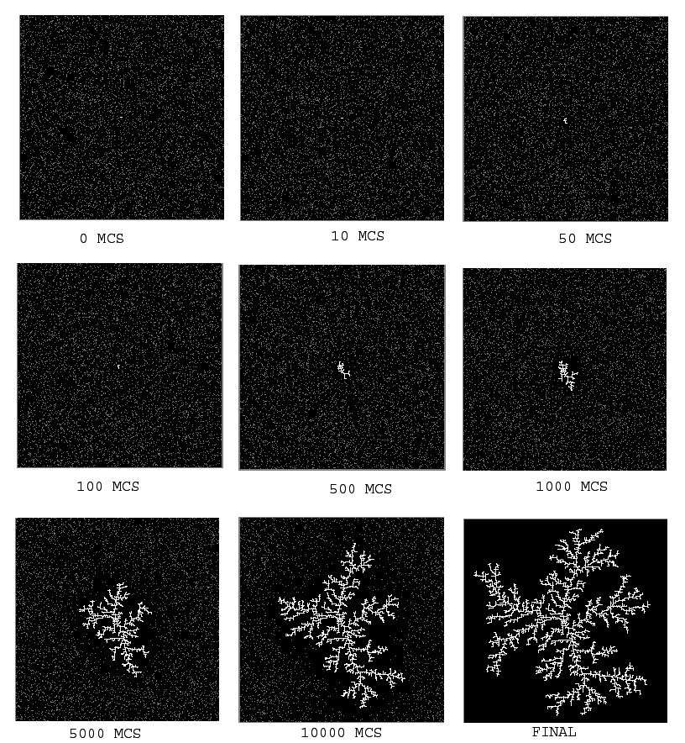

Fig.1 Sequence of snapshots showing the DLA process of a $\text{273}x\text{273}$ system with $D=0\text{.}1$. The gray and white squares represent the two types of particles $(σ_{\vec{r}}=±1)$ and the black square denotes the vacancy $(σ_{\vec{r}}=0)$. The configurations were recorded after 0 MCS, 10 MCS , 50 MCS , 100 MCS , 500 MCS , 1000 MCS , 5000 MCS, 10000 MCS, and final configuration.

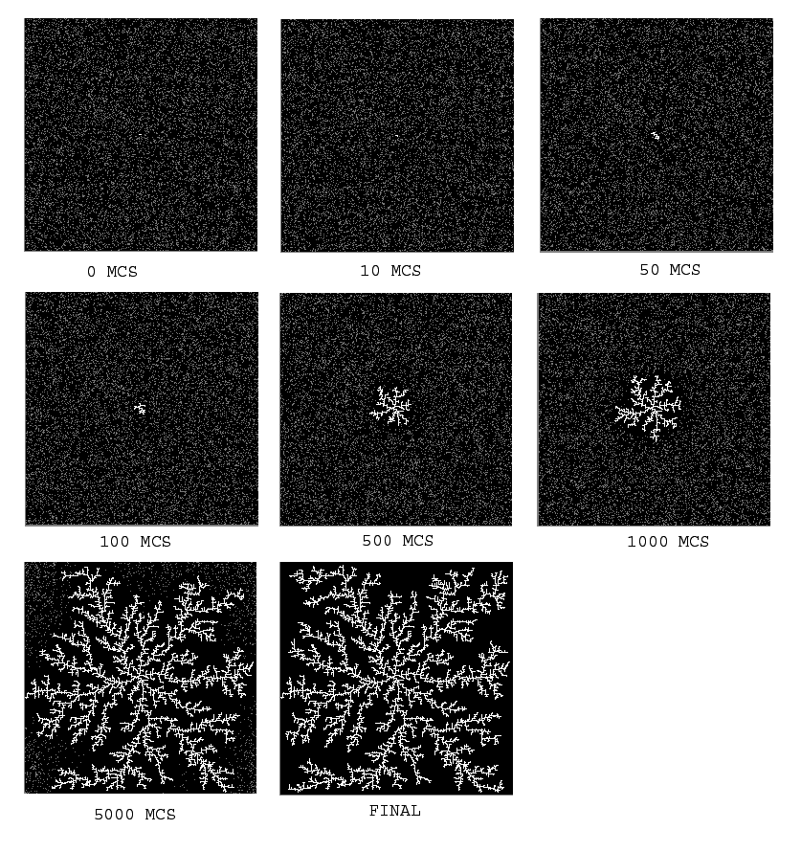

Fig.2 Sequence of snapshots showing the DLA process of a $\text{273}x\text{273}$ system with $D=0\text{.}\text{17}$. The gray and white squares represent the two types of particles $(σ_{\vec{r}}=±1)$ and the black square denotes the vacancy $(σ_{\vec{r}}=0)$. The configurations were recorded after 0 MCS, 10 MCS , 50 MCS , 100 MCS , 500 MCS , 1000 MCS , 5000 MCS, and final configuration.

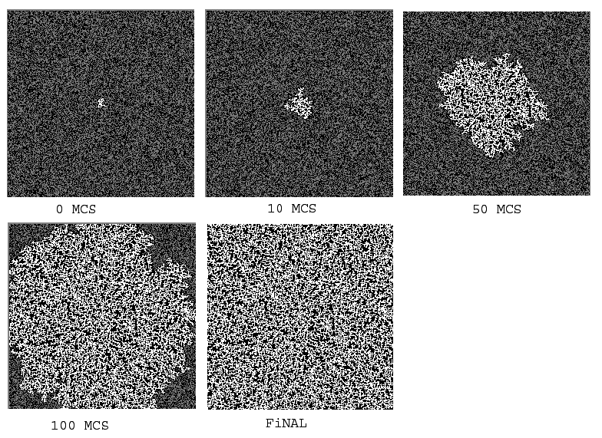
Fig.3 Sequence of snapshots showing the DLA process of a $\text{273}x\text{273}$ system with $D=0\text{.}5$. The gray and white squares represent the two types of particles $(σ_{\vec{r}}=±1)$ and the black square denotes the vacancy $(σ_{\vec{r}}=0)$. The configurations were recorded after 0 MCS, 10 MCS, 50 MCS, 100 MCS, and final configuration.

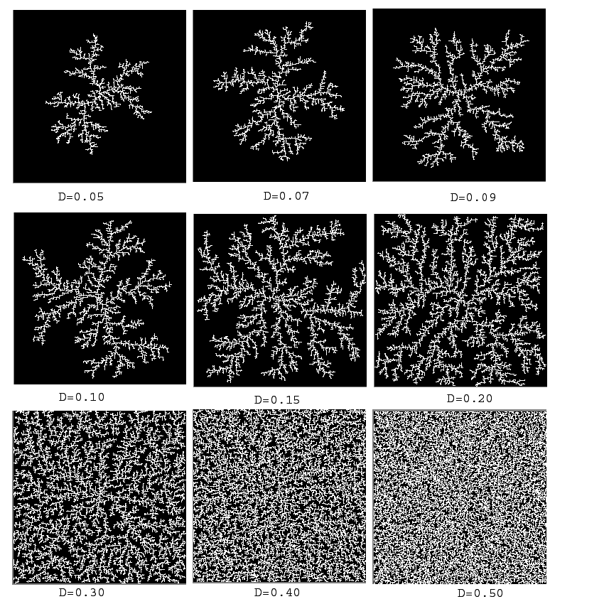
Fig.4 The final Configurations of the DLA process of a $\text{273}x\text{273}$ system. The gray and white squares represent the two types of particles $(σ_{\vec{r}}=±1)$ and the black square denotes the vacancy $(σ_{\vec{r}}=0)$. The configurations were recorded at the last step and varied the density of particles D=0.05, 0.07, 0.09, 0.10, 0.15, 0.20, 0.30, 0.40, and 0.5.

For the fractal dimension, we find that the fractal dimension rapidly growth with the density of particles, and we can fit the graph with a first order exponential decay function
$y=y_{0}+A_{1}e^{−\frac{x}{t1}}$ (5) ,
which gives y₀=2.0012±0.00127, A₁=-1.29002±0.00859, and t₁=0.08926±6.78099x10⁻⁴ with a regression coefficient R²= 0.99981 and Chi²=1.11885x10⁻⁵, shown in the Fig.5.

Fig.5 The fitting of a first order exponential function given in equation (5) with y₀=2.0012±0.00127, A₁=-1.29002±0.00859,and t₁=0.08926±6.78099x10⁻⁴ with a regression R²= 0.99981 and Chi²=1.11885x10⁻⁵.

For the lacunarity, we find that the lacunarlity rapidly decreases as the density of particles get lower, seen in the Fig.6,. Both fractal properties remain practically constant for densities higher than 0.3. In the Fig.7, we plot the log-log scale of lacunarlity versus length of box size (r).

Fig.6 the graph of the lacunarity versus Density of particles with length of box size r=3, 9, 27, and 81)

Fig.7 Plotted the log-log scale of the lacunarity versus r = 3, 9, 27, and 81 with the densities of particles D=0.05, 0.07, 0.09, 0.10, 0.11, 0.13, 0.15, 0.17, 0.19, 0.20, 0.30, 0.40, 0.50, 0.60, 0.70, 0.80, 0.90, and 1.00.
For the two-point disconnected correlation function, we can show that there is symmetry of the system about the origin. We find that there is a distance within which the two-point disconnected correlation function is positive. This correlation leagth is related to the size of the colony at each MCS, and is longer as the time go on or higher density, Fig. 8, Fig.9, and Fig. 10. The two-point disconnected correlation function with r for low densities, but is roughly constant for high densities and exactly one for unity density of particles, Fig. 11.

Fig.8 the two-point disconnected correlation function versus distances ( r ) from the origin for a particle density D=0.05 at t=0, 100, 1000, 3000 MCS.

Fig.9 the two-point disconnected correlation function versus distances ( r ) from the origin for a particle density D=0.1 at t=0, 100, 1000, 3000 MCS.

EMBED Origin50.Graph

Fig.10 the two-point disconnected correlation function versus distances ( r ) from the origin for a particle density D=0.5 at t=0,10,50, 100 MCS.

Fig.11. the two-point disconnected correlation function versus distances ( r ) from the for a particle density D=1 at t=0.
IV. Summary and Conclusions
We have investigated the Diffussion-limited aggregation process in an initially random occupation of spin up particles and with the spin down particles at the origin of lacttice and measured the fractal dimension and lacunarity of the final pattern with respect to the density of particles and the two-point disconnected correlation function with time at some densities. Our data are averaged over 10³ realizations (or runs) with the system size 81. Qualitatively, the filamental pattern can be seen in the low density of particles, and forming a compact phase and homogeneity for a high density (>0.3). The low density system takes a longer time to reach the final configuration. We find that the relation of fractal and density look like first order exponential decay, followed by
08926
.
0
1.29002
2.0012
x
e
y
−
−
=
And the lacunarity rapidly decrease when the density of particles is high. From the two point disconnected correlation, we can show that the system is symmetric about the origin and has high correlation at high densities. The correlation lengths are longer when the time goes on. The two-pointed disconnected correlation function is constant inside the correlation length for high density, but decreasing with r for low density.

Appendix
//Diffusion-limited Aggregation was done by Jirasak Wong-ekkabut
#include<stdio.h>
#include<math.h>
#include<stdlib.h>
#define M 714025
#define IA 1366
#define IC 150889
double ran(),process(),exchange(),BC(),fractal(),Lacunar(),correlate();
long seed=876587;
int f[10001][10001],x[100000],y[100000];
double L=81,D=1.;
double corl[1000][1000]={0}, corr[1000][1000]={0}, coru[1000][1000]={0}, cord[1000][1000]={0}, lac[100]={0};
int N=0,count=1,ti=0;
main()
{
int i=1,d,o,p,j=1,k=0,r=0;
double check=1,frac=0;
void initial();
FILE *fid,*fid1,*fid2,*fid3;
for(r=1;r<=1000;r++){
N=0;
k=0;
ti=0;
count=1;
initial();
correlate();
//while(count!=0){
for (k=1;k<=3000;k++){
// k++;
process();
if(k%10==0){//printf("k=%d\n",k);
ti++;
correlate();
}
}
Lacunar();
frac+=fractal();
fid = fopen("picL100D10.ppm","w");
fprintf(fid,"P2 %.0lf %.0lf 255\n\n",L,L);
for (i=1;i<=L;i++){
for (j=1;j<=L;j++){
if(f[i][j]==-1)
f[i][j]=255;
}
}
for(o=1;o<=L;o++){
for(p=1;p<=L;p++){
fprintf(fid,"%d ",f[o][p]);
}fprintf(fid,"\n");
}
fclose(fid);
fid1 = fopen("fracD10.txt","w");
fprintf(fid1,"%10lf %10lf \n",D,frac/r);
fclose(fid1);
fid2 = fopen("lacD10.txt","w");
for(p=1;p<=4;p++){
fprintf(fid2,"%10d %10lf \n",p,lac[p]/r);
}
fclose(fid2);
fid3 = fopen("corD10.txt","w");
for(p=0;p<=ti;p++){
for(d=1;d<=(L-1)/2;d++){
fprintf(fid3,"%10d %10d %10lf %10lf %10lf %10lf\n",p,d,corl[p][d]/r,corr[p][d]/r,coru[p][d]/r,cord[p][d]/r);
}
}
fclose(fid3);
}
}
void initial()
{ int i,j,k=0;
for (i=0;i<=L;i++){
for (j=0;j<=L;j++){
f[i][j]=0;
}
}
for (i=1;i<=L;i++){
for (j=1;j<=L;j++){
f[i][j]=0;
if(i==(L+1)/2&&j==(L+1)/2){
f[i][j]=-1;
}
else if(ran(&seed)<D){
f[i][j]=1;
N++;
x[N]=i;
y[N]=j;
if(f[i+1][j]==-1||f[i-1][j]==-1||f[i][j+1]==-1||f[i][j-1]==-1)
f[i][j]=-1;
}
}
}
for (i=N;i>=1;i--){
if(f[x[i]+1][y[i]]==-1||f[x[i]-1][y[i]]==-1||f[x[i]][y[i]+1]==-1||f[x[i]][y[i]-1]==-1)
f[x[i]][y[i]]=-1;
}
}
double BC(int nxo,int nyo,int *nx,int *ny){
*nx=nxo;
*ny=nyo;
if(nxo>L){
*nx=L;
}
if(nyo>L){
*ny=L;
}
if(nxo<1){
*nx=0;
}
if(nyo<1){
*ny=0;
}
}
double process(){
int i,j,nx,ny,xi,yi,r;

for(i=1;i<=N;i++){
if(f[x[i]][y[i]]==1){
r=(int)(1+ran(&seed)*4);
//printf("%d",r);
if(r==1){
xi=1;
yi=0;
}else if(r==2){
xi=-1;
yi=0;
}
else if(r==3){
xi=0;
yi=1;
}
else{
xi=0;
yi=-1;
}
nx=x[i];
ny=y[i];
BC(nx+xi,ny+yi,&nx,&ny);
//exchange
if(f[nx][ny]!=1&&f[nx][ny]!=2&&f[nx][ny]!=-1&&(nx!=x[i]||ny!=y[i])){
f[x[i]][y[i]]=0;
f[nx][ny]=2;
x[i]=nx;
y[i]=ny;
}
if(f[x[i]+1][y[i]]==-1||f[x[i]-1][y[i]]==-1||f[x[i]][y[i]+1]==-1||f[x[i]][y[i]-1]==-1)
f[x[i]][y[i]]=-1;
}
}
for (i=N;i>=1;i--){
if(f[x[i]+1][y[i]]==-1||f[x[i]-1][y[i]]==-1||f[x[i]][y[i]+1]==-1||f[x[i]][y[i]-1]==-1)
f[x[i]][y[i]]=-1;
}
count=0;
for(i=1;i<=N;i++){
if(f[x[i]][y[i]]==2){
count++;
f[x[i]][y[i]]=1;
}
}
}
double fractal(){
int i=1,j=1,k=1,l=1,m=1,o=0,n=0;
double b[100],sumx=0,sumy=0,sumxy=0,sumxx=0,frac=0,bcount=0;

while (k<L){
o++;
k*=3;
for(i=1;i<=L-k+1;i+=k){
for(j=1;j<=L-k+1;j+=k){
for(l=i;l<=i+k;l++){
for(m=j;m<=j+k;m++){
if(f[l][m]==-1){
bcount+=1;
m=j+k;
l=i+k;//printf("c%d %lf\n",k,bcount);
}
}
}
}
}
b[o]=log(bcount);
bcount=0;//k*=2;
}
k=1;
m=0;
for(i=1;i<=o;i++){
k*=3;//printf("4%d %lf\n",k,b[i]);
sumx+=log(k);
sumy+=b[i];//printf("2 %lf\n",sumy);
sumxy+=log(k)*b[i];//printf("3 %lf\n",sumxy);
sumxx+=log(k)*log(k);
}
frac=(((o)*sumxy)-(sumx*sumy))/(((o)*sumxx)-(sumx*sumx));
return(-frac);
}
double Lacunar()
{
int i=1,j=1,k=1,l=1,m=1,n=0,o=0,p=0;
double b[100000],La1[100],La2[100],h[100],Q=0,Z1=0,Z2=0,bcount=0,g1,g2;
while (k<L){
k*=3;
o++;
for(i=1;i<=L-k+1;i+=k){
for(j=1;j<=L-k+1;j+=k){
p++;
for(l=i;l<=i+k;l++){
for(m=j;m<=j+k;m++){
if(f[l][m]==-1){
bcount+=1;
if(bcount==1)
n++;
}
}
}
b[p]=bcount;
bcount=0;
}//p=0;
}
h[o]=n;
Q= (double)n/(double)p;
for(i=1;i<=p;i++){
//g1+=b[i];
//g2+=b[i]*b[i];
Z1+=b[i]*Q;//printf("%lf\n",Q);
Z2+=b[i]*b[i]*Q;
}
La1[o]=Z2/(Z1*Z1);
// La2[o]=g2/(g1*g1)+1;
// k*=2;
lac[o]+=La1[o];
//printf("Lacunarity1 %d %lf\n",o,La1[o]);
// printf("Lacunarity2 %d %lf\n",o,La2[o]);
p=0;
n=0;
}

}
double correlate(){
int i;
//double corl[100]=0,corr[100]=0,coru[100]=0,cord[100]=0;
for(i=1;i<=(L-1)/2;i++){
corl[ti][i]+=-1*f[(int)((L+1)/2)-i][(int)(L+1)/2];
corr[ti][i]+=-1*f[(int)((L+1)/2)+i][(int)(L+1)/2];
coru[ti][i]+=-1*f[(int)(L+1)/2][(int)((L+1)/2)-i];
cord[ti][i]+=-1*f[(int)(L+1)/2][(int)((L+1)/2)+i];
}
}
double ran(idum)
long *idum;
{
static long iy,ir[98];
static int iff=0;
int j;
// void nrerror();
if (*idum < 0 || iff == 0) {
/* INITIALIZE SEQUENCE */
iff=1;
if ((*idum=(IC-(*idum)) % M) < 0) *idum = -(*idum);
for (j=1;j<=97;j++) {
*idum=(IA*(*idum)+IC) % M;
ir[j]=(*idum);
}
*idum=(IA*(*idum)+IC) % M;
iy=(*idum);
} /* START HERE UNLESS INITIALIZING. */
/* RANDOMLY SELECT NUMBER FROM SEQUENCE. */
j=1 + 97.0*iy/M;
iy=ir[j];
*idum=(IA*(*idum)+IC) % M;
ir[j]=(*idum);
return (double) iy/M;
}

Diffusion-Limited Aggregation (DLA)

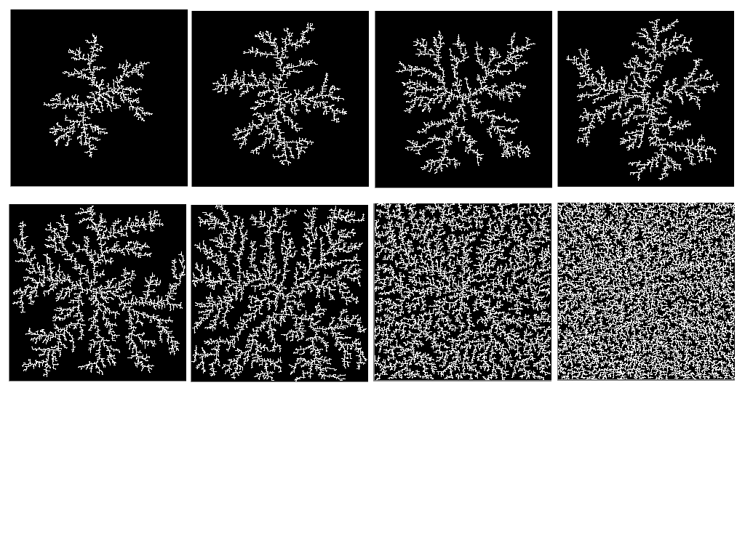
Presented By
Jirasak Wong-ekkabut g4637336

Counselor
Alejandro Saiz

